Nervous System Quiz 2 Name ______________________________

- List four things that the cerebrum enables us to do (4 marks)

- Compare and contrast the roles of the cerebellum and medulla. (3 marks)

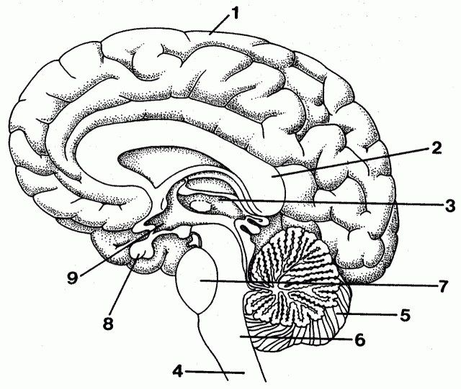
- What does the corpus callosum do and which number is it on the diagram? (2 marks)

- What is number: (3 marks)
1)____________________________
6)____________________________
5)____________________________

Nervous System Quiz 2 Name ______________________________

- List four things that the cerebrum enables us to do (4 marks)

- Compare and contrast the roles of the cerebellum and medulla. (3 marks)


- What does the corpus callosum do and which number is it on the diagram? (2 marks)

- What is number: (3 marks)
1)____________________________
6)____________________________
5)____________________________

- Explain how a reflex arc works (5 marks)

- How is a simple reflex different to a complex reflex? Give an example of each (4 marks)

- Explain how a reflex arc works (5 marks)

- How is a simple reflex different to a complex reflex? Give an example of each (4 marks)

